# Quinte Financial Technologies | FinTech Solutions

**Assignment on**

**U.S. BANKING SYSTEM**

**Under Supervision of:**

**Mr. Mohammad Mozammil**

**Submitted On:**

**4th June, 2024**

**Submitted By:**

**Archita Gupta**

# U.S. Banking System

The United States' banking system took root in the 1780s, coinciding with the nation's establishment. Over time, it has evolved into an intricate and influential network of banking and financial services. With New York City and Wall Street serving as its hub, the system revolves around various financial services, including private banking, asset management, and deposit protection mechanisms.

The Federal Reserve System is the central banking system of the United States. It was created in 1913 in response to a series of financial panics. The Federal Reserve System is responsible for setting monetary policy, regulating banks, and providing financial services to banks.

Contents

History 4

Early Beginnings (1780s): 4

Pre-Central Bank Era (1836-1913): 4

The Federal Reserve System's Birth (1913): 5

Present 6

Recent Trends: 8

## History

### ****Early Beginnings (1780s):****

In the early years of the United States, during the American Revolutionary War from 1775 to 1783, a group of merchants from Britain ventured to the newly formed nation and founded the Bank of Pennsylvania in 1780. Their objective was to secure funding for the ongoing war efforts. At that time, the country lacked an established currency system, and informal trade practices were commonly employed to facilitate daily financial transactions. Subsequently, on January 4, 1782, the nation's first commercial bank commenced its operations within the United States, *Bank of North America*, with the aim to:

* Manage the national debt
* Establish a uniform national currency
* Facilitate trade by providing credit and stability

It achieved some of its goals but faced political opposition, particularly from those who feared giving too much power to the federal government.

In 1791, U.S. Treasury Secretary Alexander Hamilton created the Bank of the United States, a national bank intended to maintain American taxes and pay off foreign debt (similar goals to first commercial bank). However, President Andrew Jackson closed the bank in 1832 and redirected all bank assets into U.S. state banks as it also faced political opposition and due to distrust in concentrated financial power.

### ****Pre-Central Bank Era (1836-1913):****

Also known as The “Free Banking” Era saw a rapid rise in the number of banks, often with limited regulations. There was no central bank. State-chartered banks issued their own banknotes, leading to a lack of uniformity in currency value. Unregulated lending practices and economic downturns resulted in frequent bank failures, causing financial hardships for citizens.

Panic of 1837**-** A major financial crisis exemplified the system's vulnerabilities; triggered due to excessive speculation in land, overextension of credit by banks, and President Andrew Jackson's economic policies like the Specie Circular. Almost half of the banks in the U.S. (618 banks) failed between 1837 and 1843 which led to severe economic depression, business failures, unemployment, price declines, and collapse of land values.

Panic of 1907- Another major financial crisis that rocked the United States banking system; triggered by a failed attempt to corner the market on the stock of the United Copper Company, leading to a stock market sell-off and a run on banks (the Knickerbocker Trust Company, one of the largest trusts in New York, experienced devastating bank runs) leading to their failure. The panic led to a severe liquidity crisis, with interest rates spiking, resulting in businesses failing and reduced economic activity.

Overall the period was marked by instability with numerous bank failures due to a lack of central oversight. It highlighted the need for a central banking system, leading to the establishment of the Federal Reserve System in 1913 to provide stability and regulation to the banking industry.

### The Federal Reserve System's Birth (1913):

Created in response to financial panics, the Fed became the central bank, responsible for monetary policy, bank regulation, and financial stability.

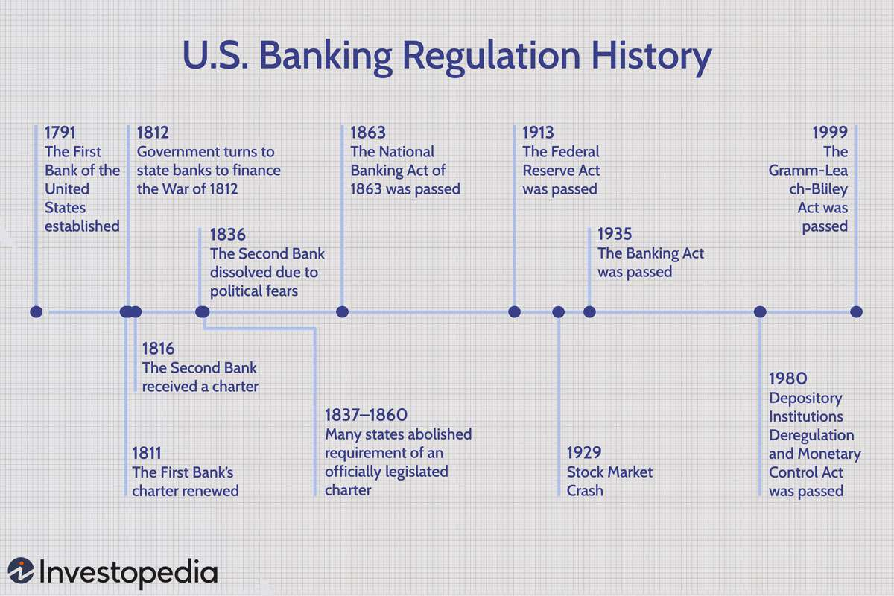

## 

## ****Present****

The structure of the US banking system can be divided into two main parts:

**1. The Federal Reserve System (The Fed):**

The Fed is a complex system with several key entities working together:

* **Board of Governors:** Appointed by the President and confirmed by the Senate, these seven individuals oversee the entire Federal Reserve System. They set monetary policy by determining the federal funds rate, which influences other interest rates in the economy.
* **Federal Reserve Banks:** There are twelve regional Federal Reserve Banks located throughout the US. They:
  + Hold reserves for member banks.
  + Provide financial services to banks, including lending and check clearing.
  + Implement monetary policy directives set by the Board of Governors.
* **Federal Open Market Committee (FOMC):** This committee, made up of the Board of Governors and five representatives from the Federal Reserve Banks, sets the target federal funds rate through open market operations.

**2. Depository Institutions:**

These ‘banks’ are chartered by either the federal government or individual states and offer a range of financial services to consumers and businesses. Main types of banks are:

* **Commercial Banks:** These are the most common type of depository institution which offer checking and savings accounts, business loans, mortgages, credit cards, and other financial products. They generate profit by charging interest on loans and fees for services and making money on investments.
* **Savings Institutions:** These institutions traditionally specialize in deposit accounts (like savings accounts and money market accounts) and home loans. However, the lines between them and commercial banks are blurring as they offer more and more similar services.
* **Credit Unions:** These are non-profit cooperatives owned by their members (depositors). They offer similar products and services to commercial banks, but typically with lower fees and more competitive interest rates on deposits.

It's important to understand that the Fed doesn't directly serve the public. You cannot open a checking or savings account with the Federal Reserve. They provide financial services to depository institutions and the government, and act as a lender of last resort during financial crises.

### Recent Trends:

* Consolidation: The number of banks has been declining due to mergers and acquisitions, leading to a more concentrated industry with a few large players dominating the market.
* Technology Revolution: Digitalization has transformed banking. Online and mobile banking have become increasingly popular, offering convenience and efficiency. Fintech (financial technology) companies are disrupting traditional banking models with innovative solutions.
* Cyber security Concerns: As banks rely more on technology, they face growing threats from cyber-attacks. Data breaches and financial fraud are constant risks that require robust security measures.
* Post-Crisis Regulations: In response to the 2008 financial crisis, stricter regulations aim to prevent future meltdowns. These include capital adequacy requirements (banks must hold a certain amount of capital to absorb losses) and stress testing (assessing banks' ability to withstand economic shocks).
* Focus on Consumer Protection: Regulations and consumer awareness initiatives aim to protect individuals from predatory lending practices and unfair fees.

The US banking system is constantly evolving, navigating technological advancements, regulatory changes, and a dynamic economic environment. The ability to adapt and innovate will be crucial for banks to remain competitive and serve the needs of their customers in the years to come.

THANK YOU